Exercise 1: Configuring a Basic Spring Application
Scenario:
Your company is developing a web application for managing a library. You need to use the Spring Framework to handle the backend operations.
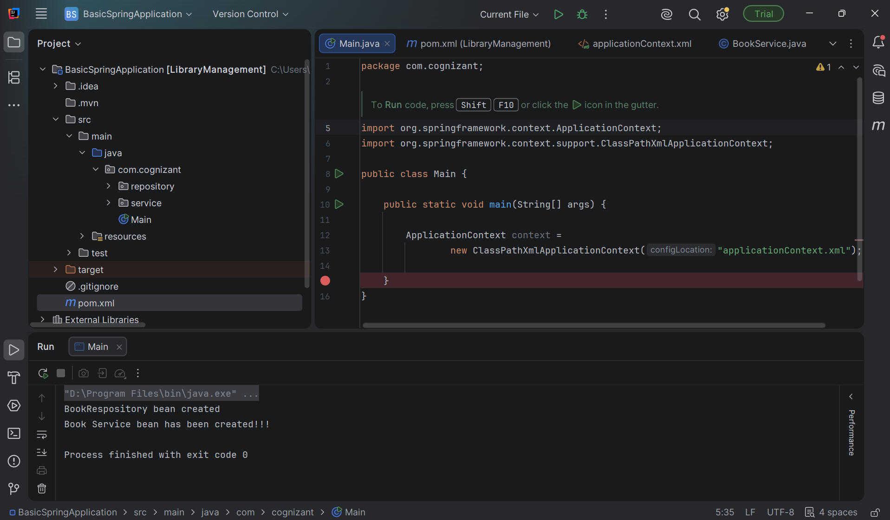

Exercise 2: Implementing Dependency Injection
Scenario:
In the library management application, you need to manage the dependencies between the BookService and BookRepository classes using Spring's IoC and DI.
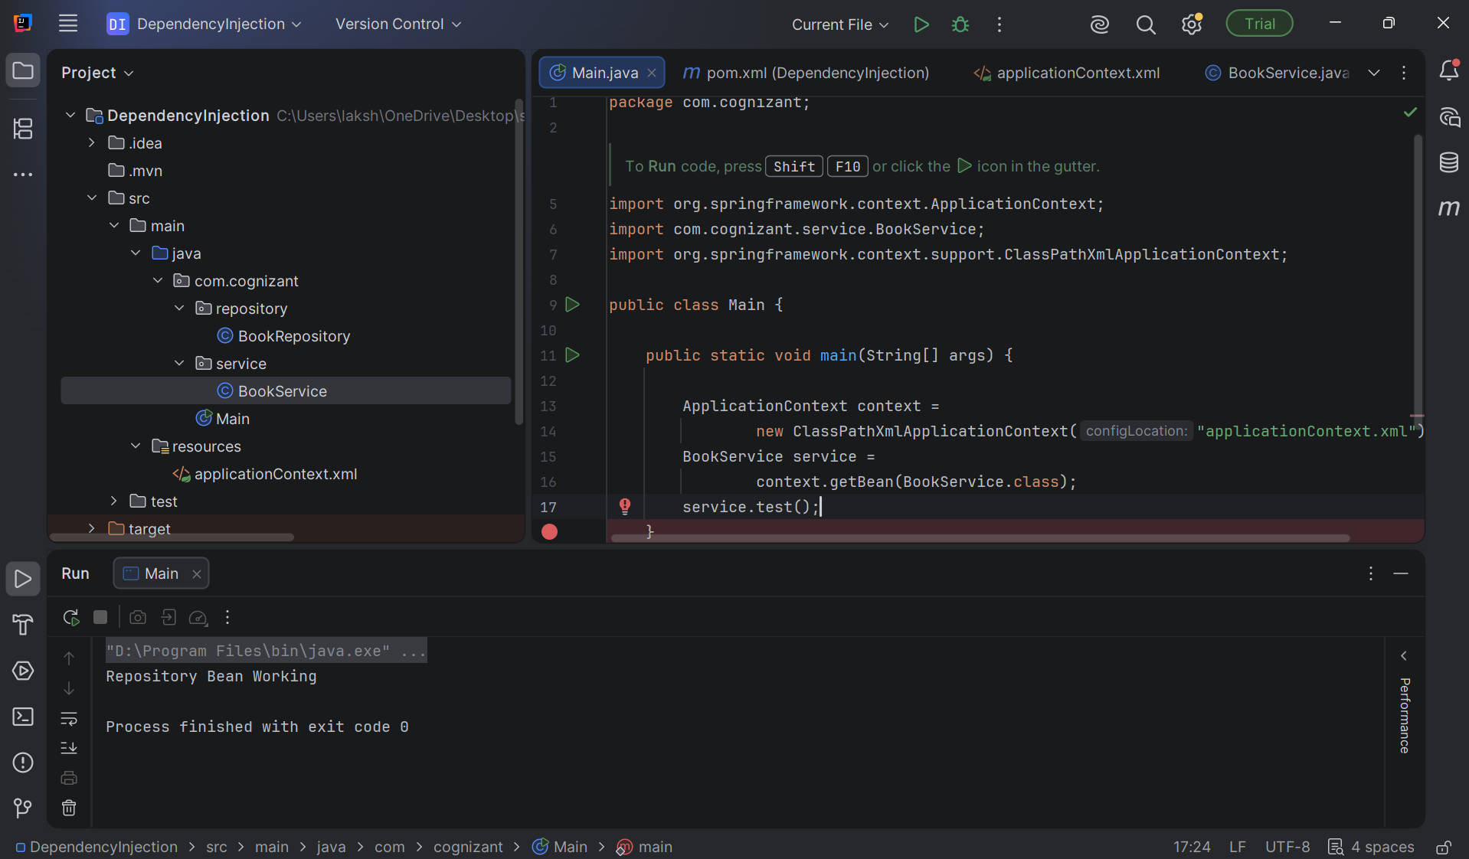

Exercise 3: Implementing Logging with Spring AOP
Scenario:
The library management application requires logging capabilities to track method execution times.
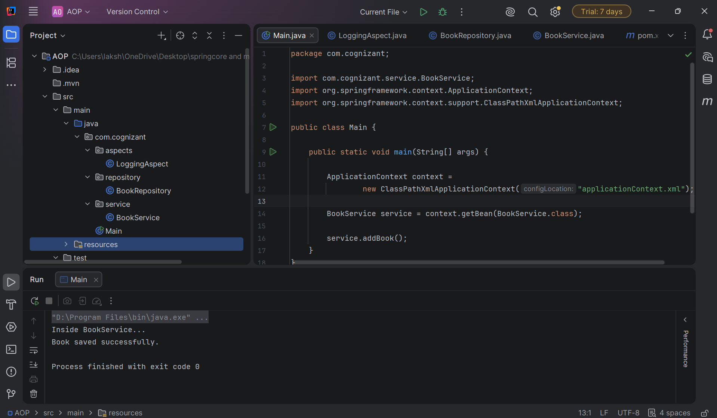

Exercise 4: Creating and Configuring a Maven Project
Scenario:
You need to set up a new Maven project for the library management application and add Spring dependencies.
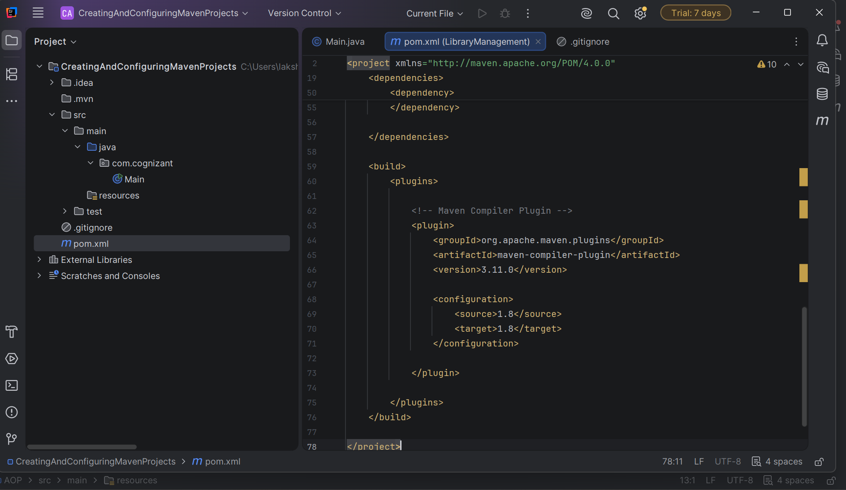

Exercise 5: Configuring the Spring IoC Container
Scenario:
The library management application requires a central configuration for beans and dependencies.
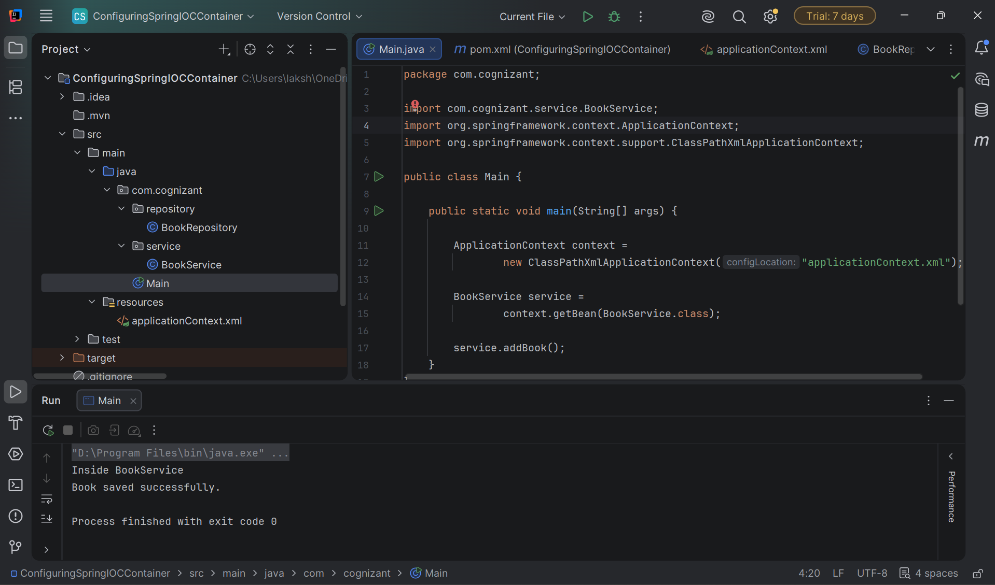

Exercise 6: Configuring Beans with Annotations
Scenario:
You need to simplify the configuration of beans in the library management application using annotations.
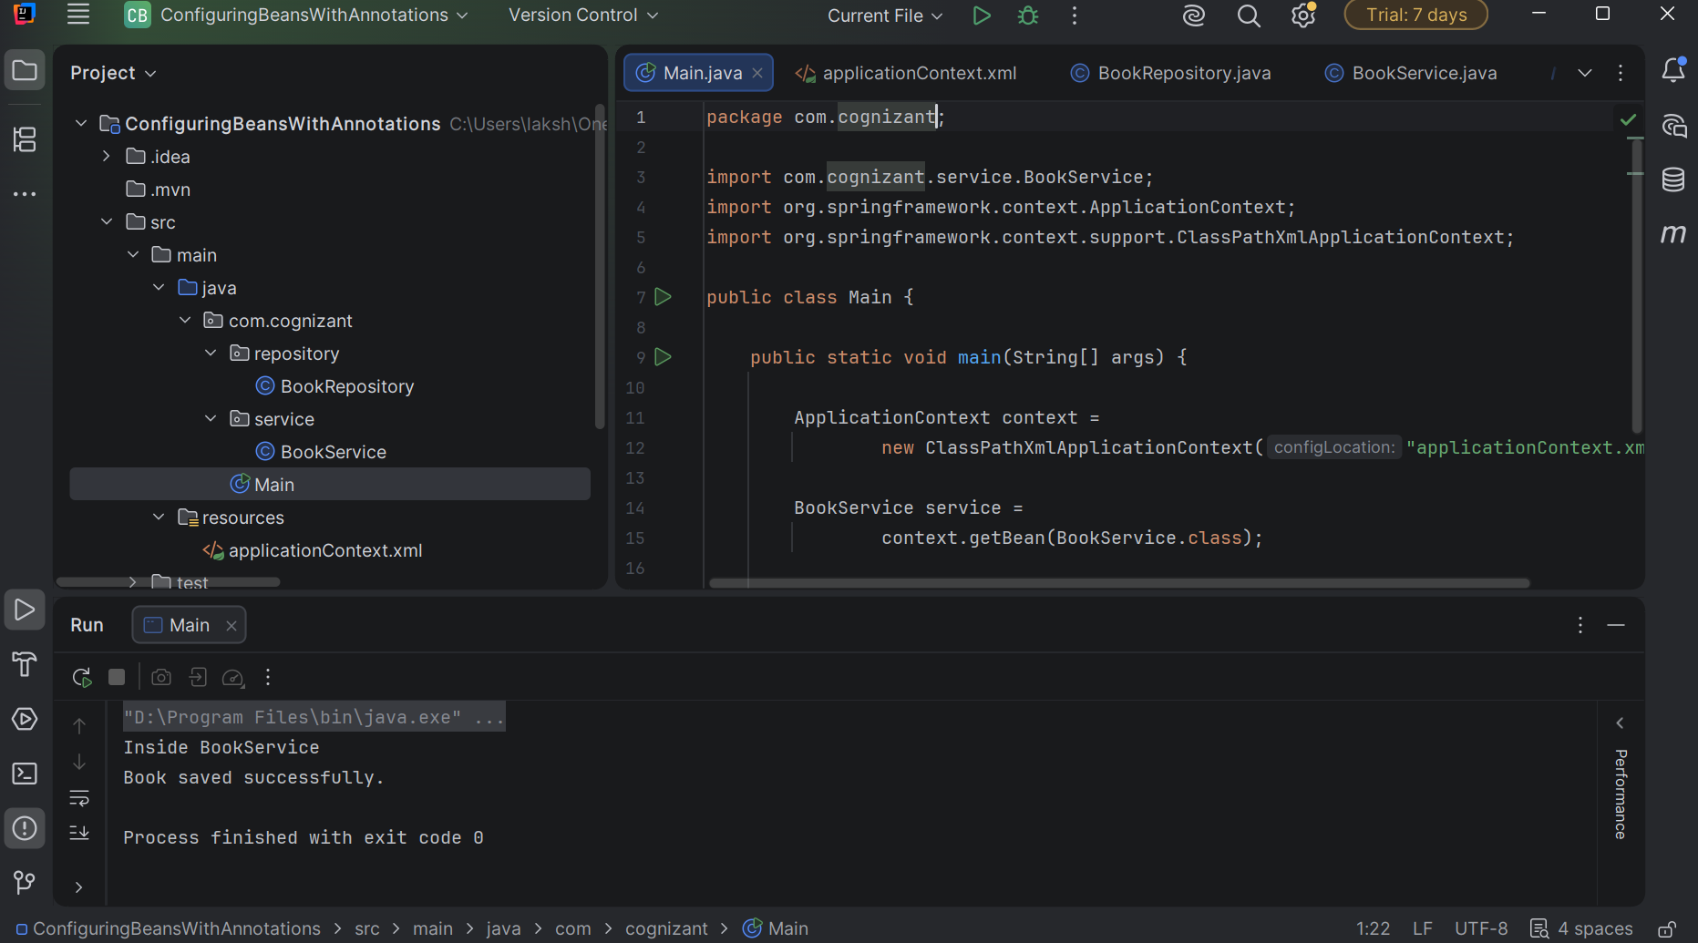

Exercise 7: Implementing Constructor and Setter Injection
Scenario:
The library management application requires both constructor and setter injection for better control over bean initialization.
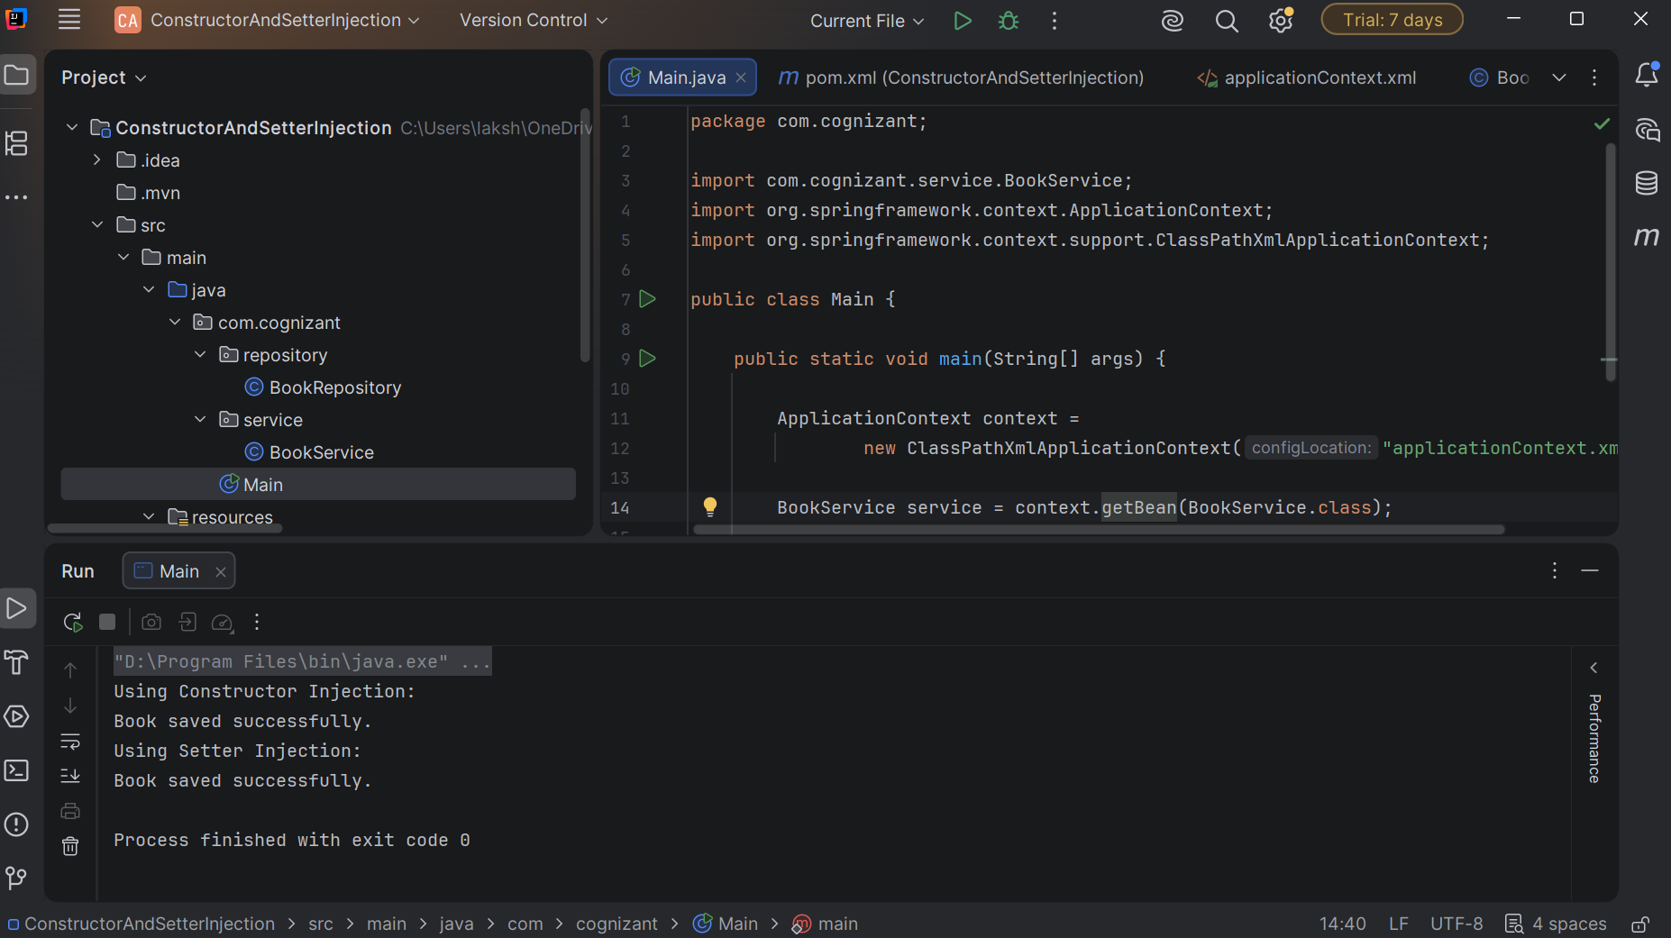

Exercise 8: Implementing Basic AOP with Spring
Scenario:
The library management application requires basic AOP functionality to separate cross-cutting concerns like logging and transaction management.
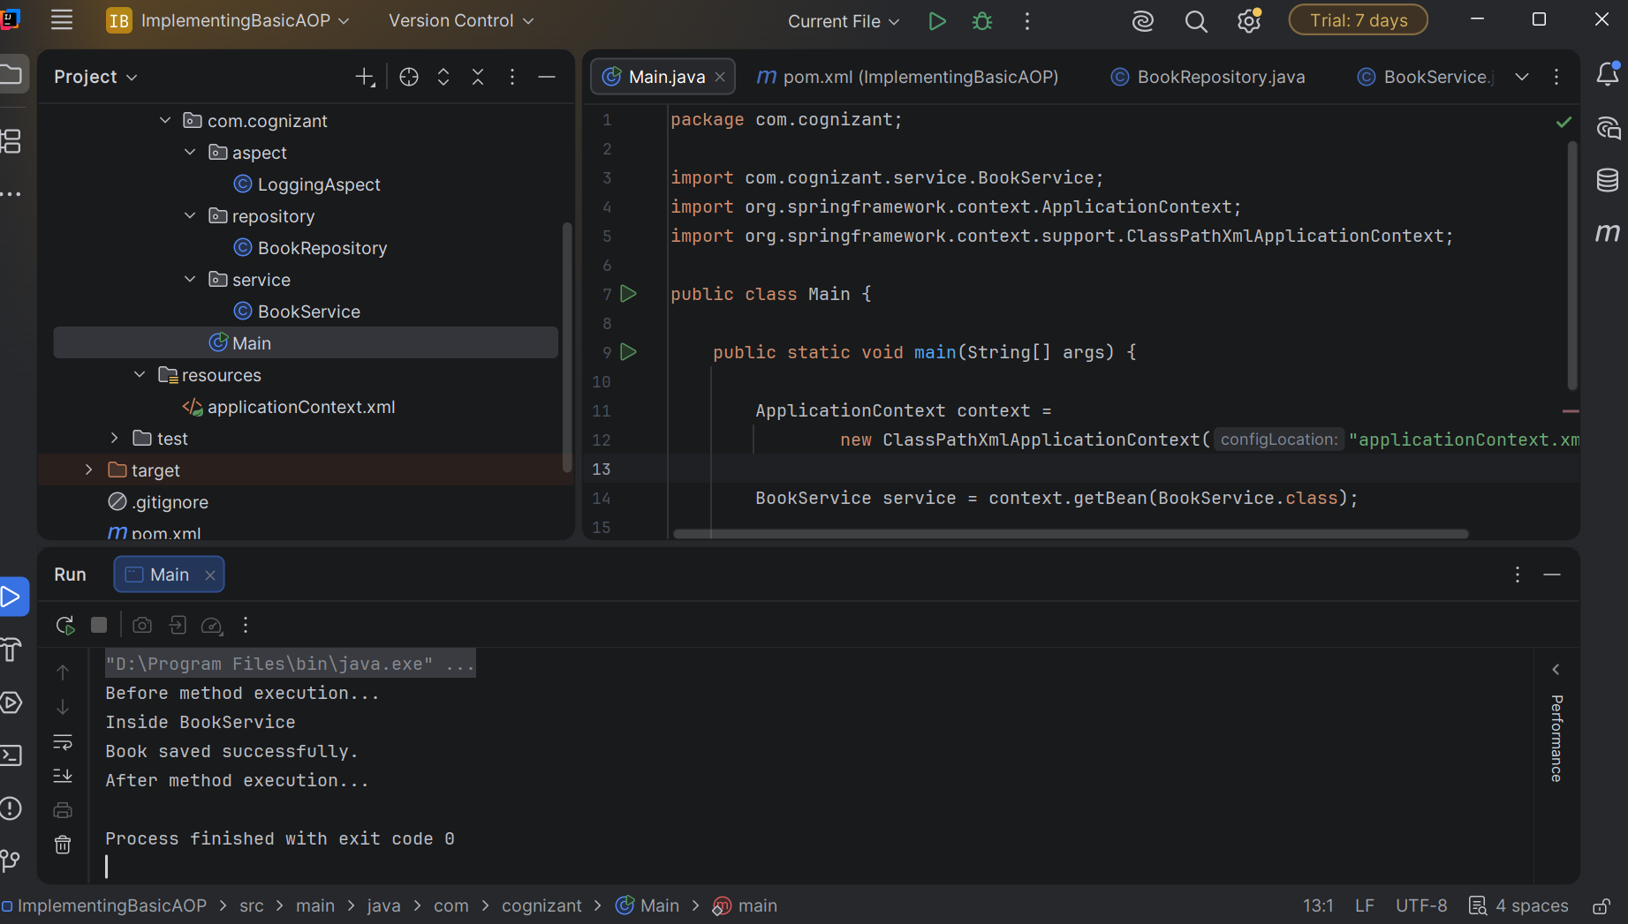

Exercise 9: Creating a Spring Boot Application
Scenario:
You need to create a Spring Boot application for the library management system to simplify configuration and deployment.
